

Landscaping Services

Transforming Outdoor Spaces
Halcyon Landscapes delivers high quality landscaping across Bradford, West Yorkshire and nearby towns. We create practical, long lasting outdoor spaces designed to suit your lifestyle, your home and the Yorkshire climate.

Complete Landscaping Services
We manage every stage of your garden project, including:
• Full garden makeovers
• Hard landscaping (patios, paths, edging, retaining walls)
• Soft landscaping (planting schemes, turfing, beds and borders)
• Decking and timber structures
• Fencing and screening
• Drainage improvements and levelling
• Garden lighting integration
• Finishing touches for a complete transformation

Designed Around Your Home
We take time to understand how you want your garden to function, whether it is a relaxation space, a family friendly layout, a low maintenance solution or something more premium.

Local Knowledge Matters
We work across Bradford, Bingley, Shipley, Keighley, Ilkley, Skipton and surrounding areas. Our understanding of local soil, gradients and weather patterns helps us choose the right materials and methods for lasting results.

A Straightforward Process
1. Site visit and consultation
2. Clear written quote
3. Design and planning if needed
4. Professional installation
5. Handover with maintenance guidance

Why Choose Halcyon Landscapes?
• Local, reliable and friendly
• High quality workmanship
• Sensible pricing with no hidden extras
• Fully insured and experienced
• Strong reputation across West Yorkshire
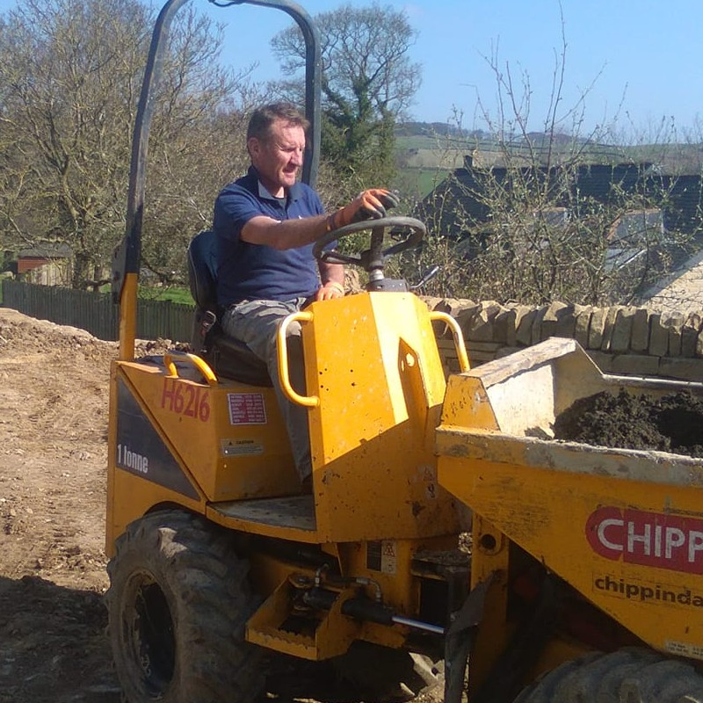
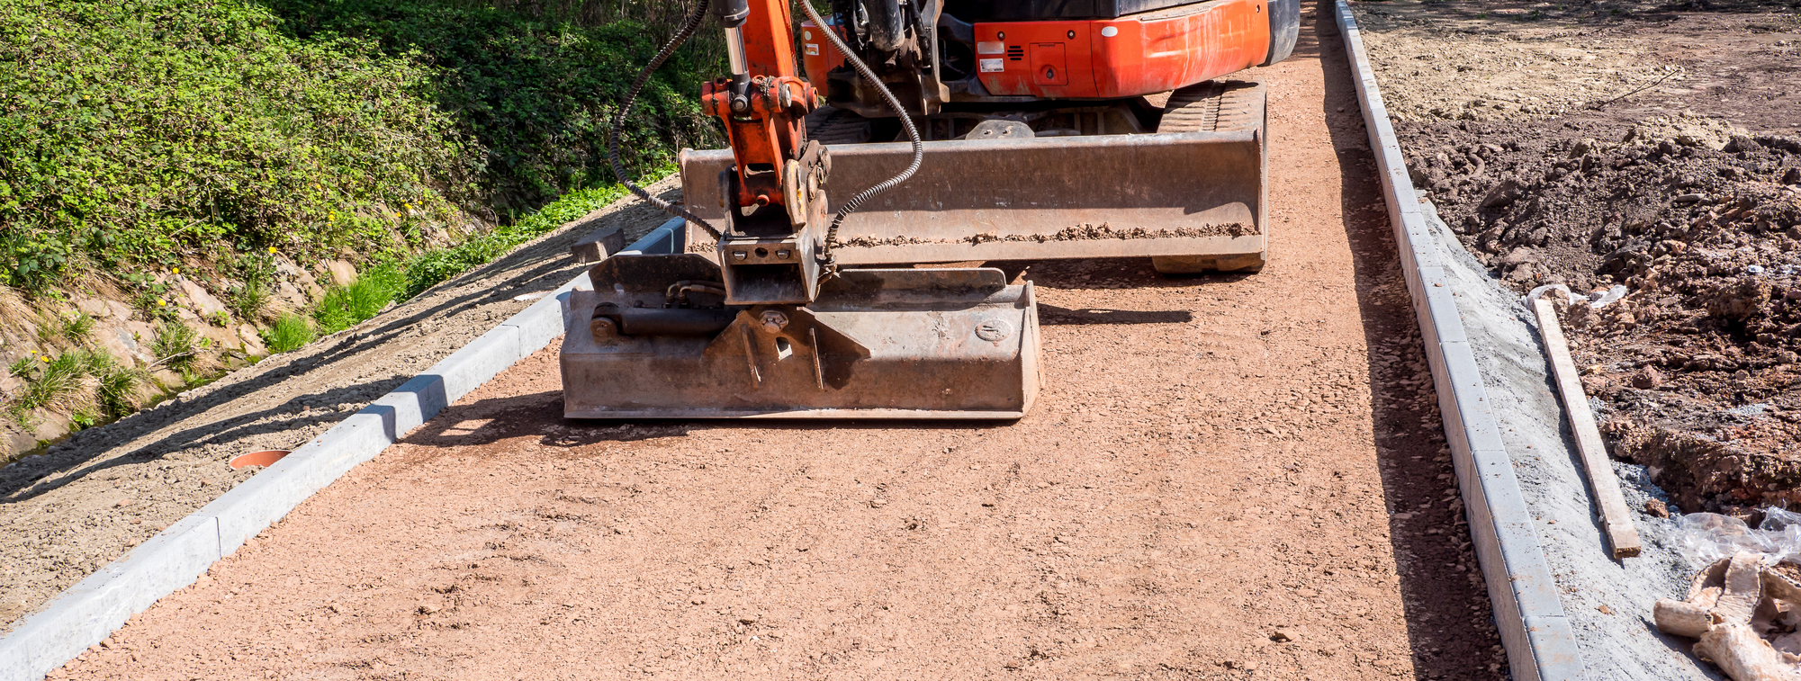

Contact Information
Halcyon Landscapes (Yorkshire) Ltd.
155 Moorside Road, Bradford, BD2 3HD
Web: https://halcyonlandscapes.co.uk/
Phone: 07771 912547
Email: nigel@halcyonlandscapes.co.uk

