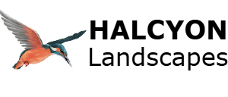

Artificial Grass
Enjoy a neat, low maintenance lawn all year round with professionally installed artificial grass. Halcyon Landscapes supply and install high quality artificial turf across Bradford and West Yorkshire.
Artificial grass is ideal for busy families, shaded or high-traffic areas, pet friendly spaces, rental properties and gardens where real turf struggles.
Our installation includes ground preparation, weed-resistant membrane installation, compacted sub base, turf jointing, secure perimeter fixing and sand infill where required.
We also offer pet friendly systems with fast draining layers, odour reducing infills, easy clean surfaces and strong fibres.
Artificial grass stays neat all year, requires no mowing, produces no mud, and is long lasting with minimal upkeep.
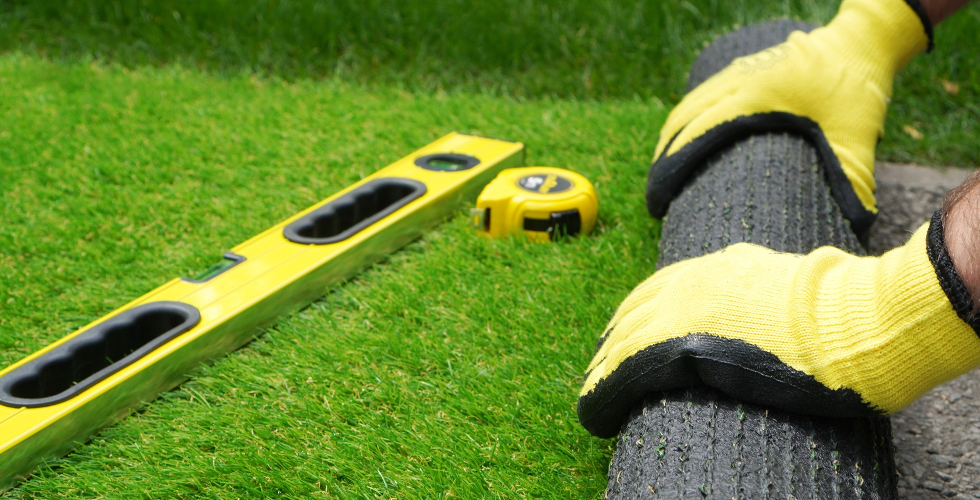
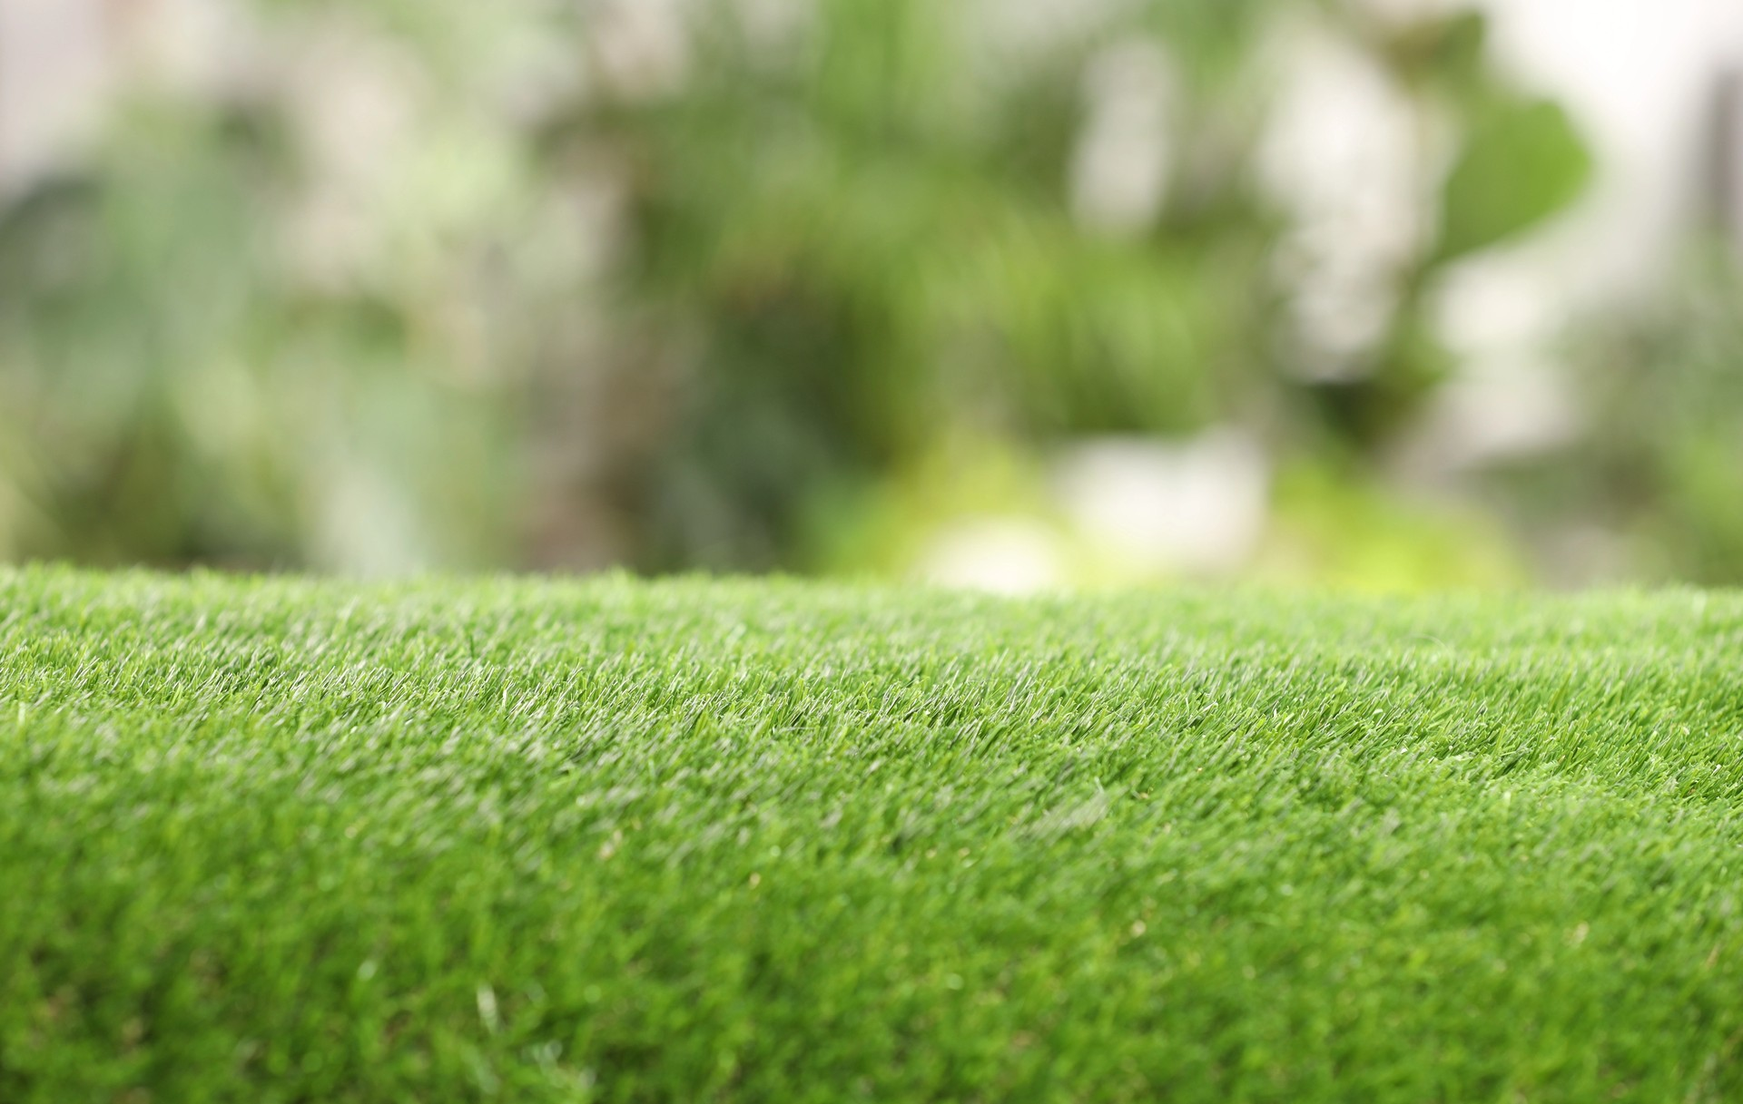

Contact Information
Halcyon Landscapes (Yorkshire) Ltd.
155 Moorside Road, Bradford, BD2 3HD
Web: https://halcyonlandscapes.co.uk/
Phone: 07771 912547
Email: nigel@halcyonlandscapes.co.uk

